**Supply and Distribution Management System**

**Design Documentation**

|  |  |
| --- | --- |
| **Roll No.** | **Name** |
| **CS-062** | **Sachin Karmani** |
| **CS-023** | **Ruhail Mangi** |
| **CS-067** | **Deepak Kumar** |

**Entity Relationship Diagram:**

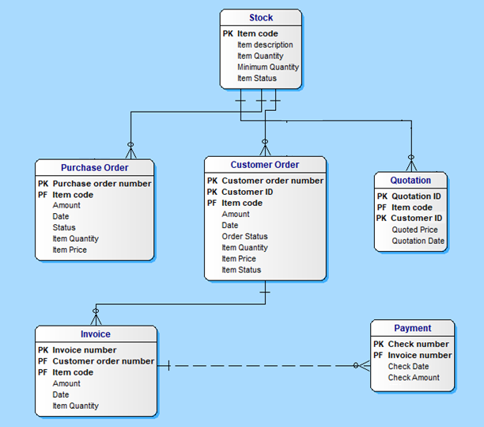

**Use Case Diagram:**

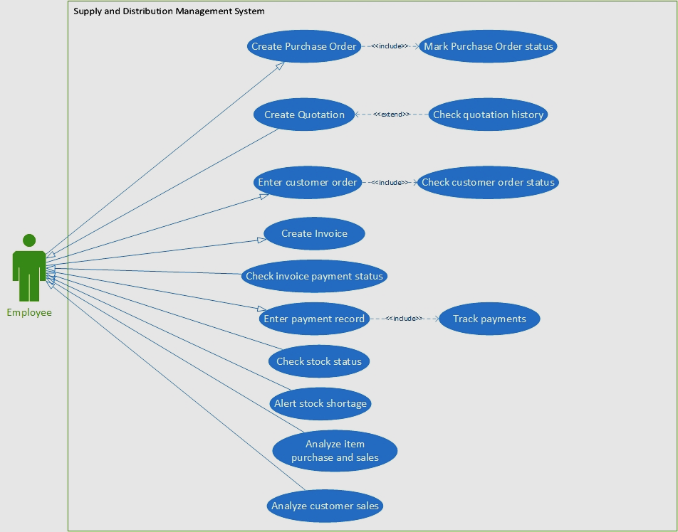

**Sequence Diagram:**

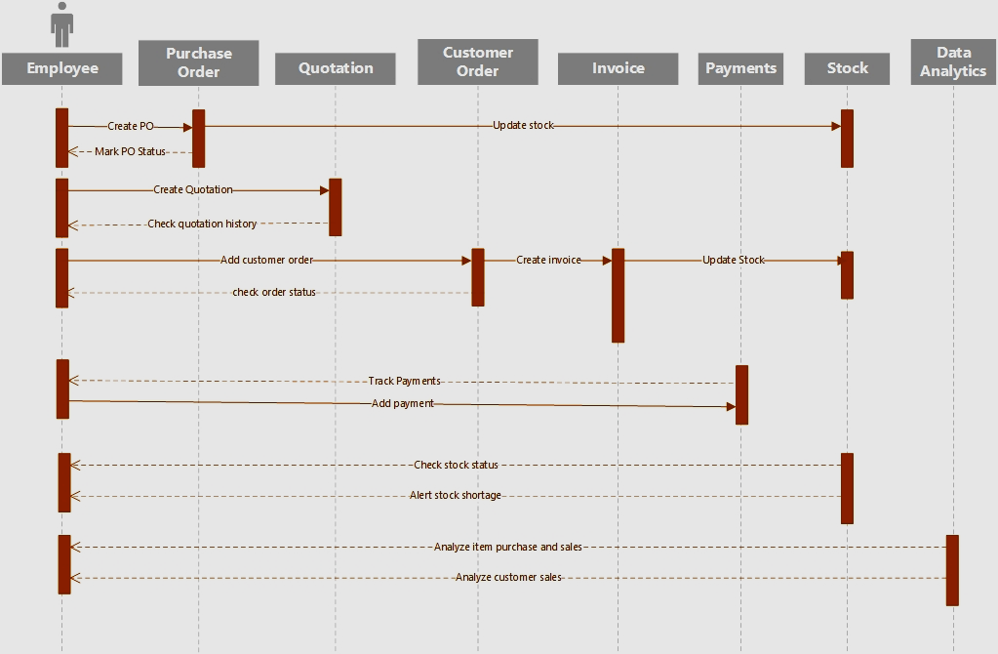

**Data Flow Diagram Level 0:**

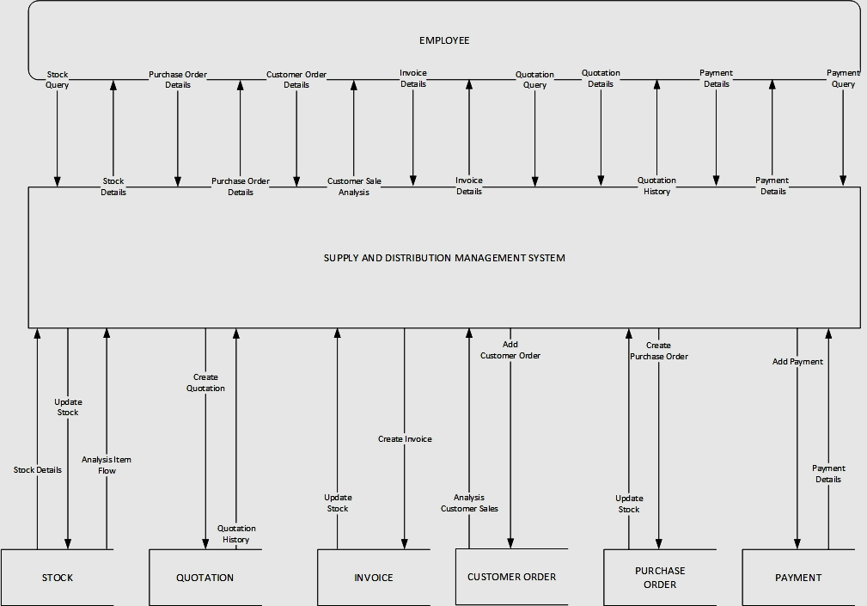

**Data Flow Diagram Level 1:**

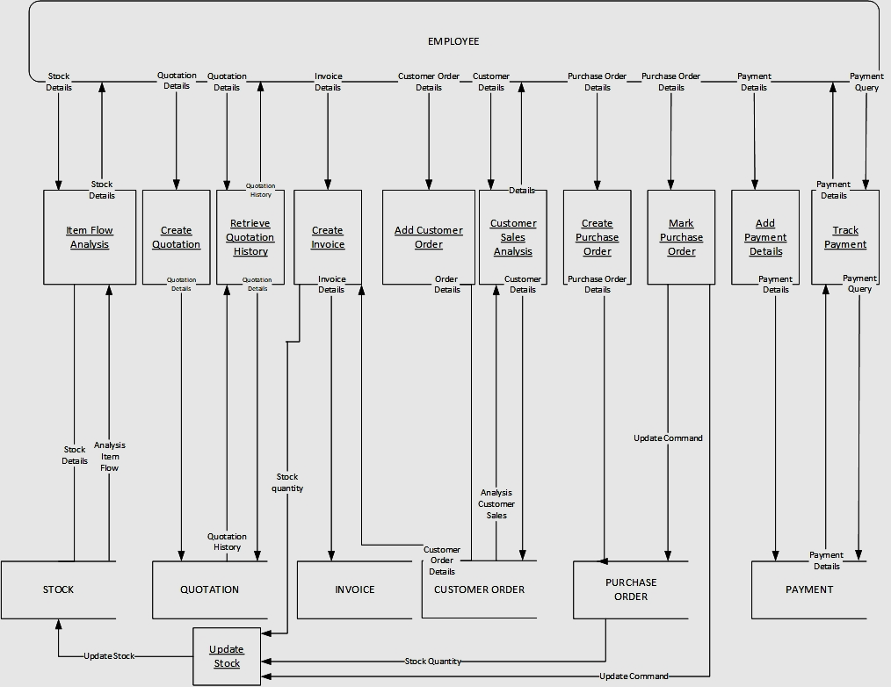

**Class Diagram:**

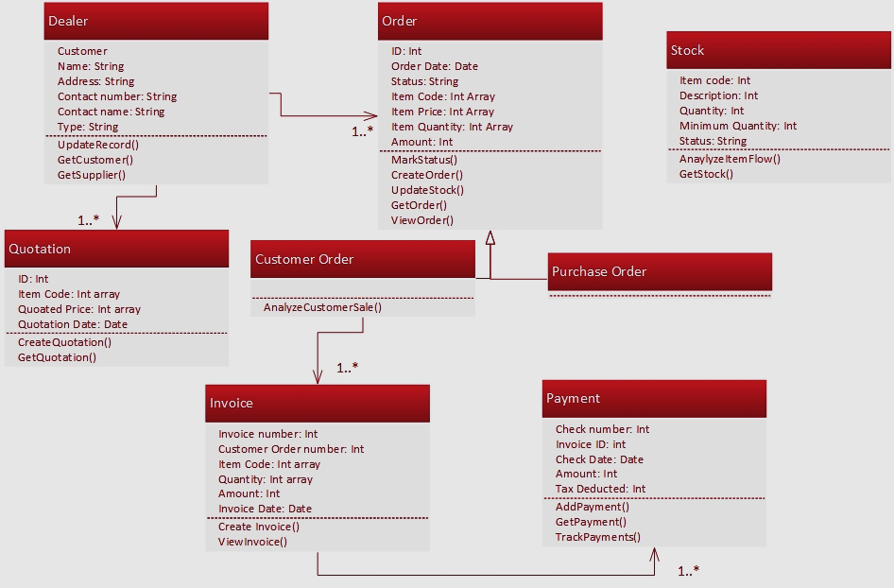

**State Transition Diagram:**

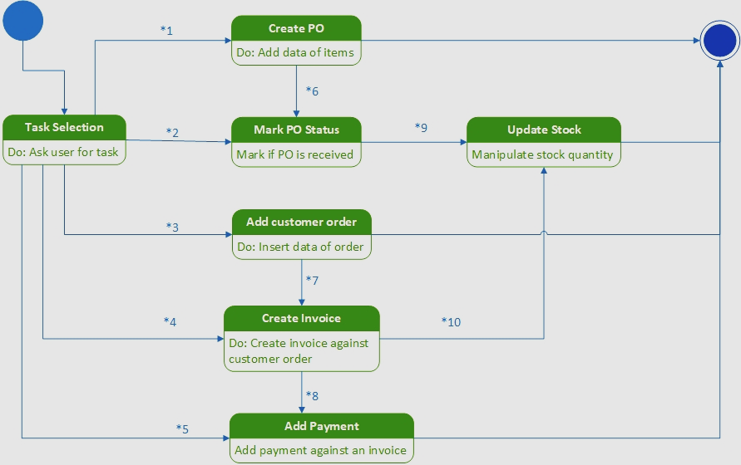

|  |  |
| --- | --- |
| State Transition Reference Table | |
| Index | Description |
| *1 | Select ‘Create PO’ |
| *2 | Select ‘Mark PO Status’ |
| *3 | Select ‘Add Customer Order’ |
| *4 | Select ‘Create Invoice’ |
| *5 | Select ‘Add Payment’ |
| *6 | Mark if PO item received at time of creation of PO |
| *7 | Create invoice at the time of adding customer order |
| *8 | Add payment if receiver at time of creating invoice |
| *9 | Add stock if PO received |
| *10 | Reduce stock when items (in invoice) dispatched |